**Assignment 6 – Programming Project 1: Dive Score**

I started this assignment by declaring an array to hold the scores and a double for the difficulty rating. Originally, I was going to try some kind of ‘min’ and ‘max’ evaluation of the array. After thinking more about it, I realized I could use the sort function to arrange the scores and just remove the first and last indices – the highest and lowest scores. I then added them together, multiplied them by the difficulty, and finally by .6 to produce the score. I then wrapped that method in a couple of if statements to check the scores and difficulty ratings for validity.

**Screenshot of main.java(1/2)**

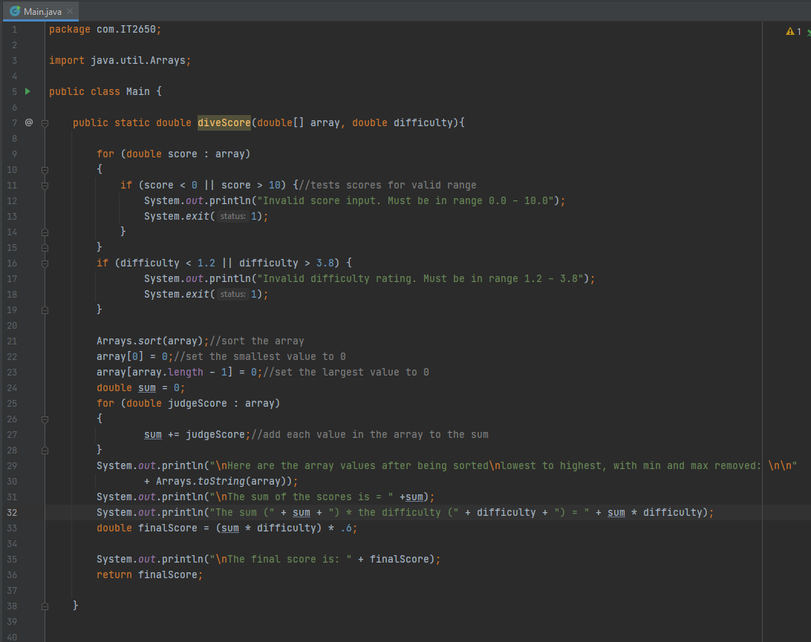

**Screenshot of main.java(2/2)**

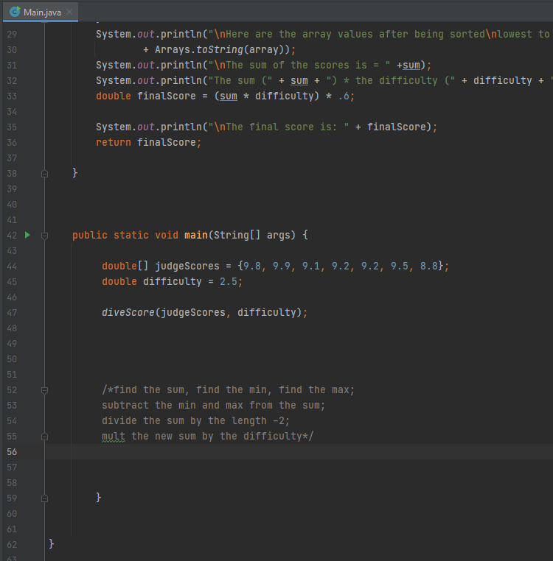

**Screenshot of output**

